INSTALLATION STEPS FOR OUR GAME

This is a complete guide on how to install our game, Forza 4.

The first thing to do is open our github main page at the address <https://github.com/LUCADN4/GameAbility2k22>, then open the “codice” folder and inside you will find every class of our program.

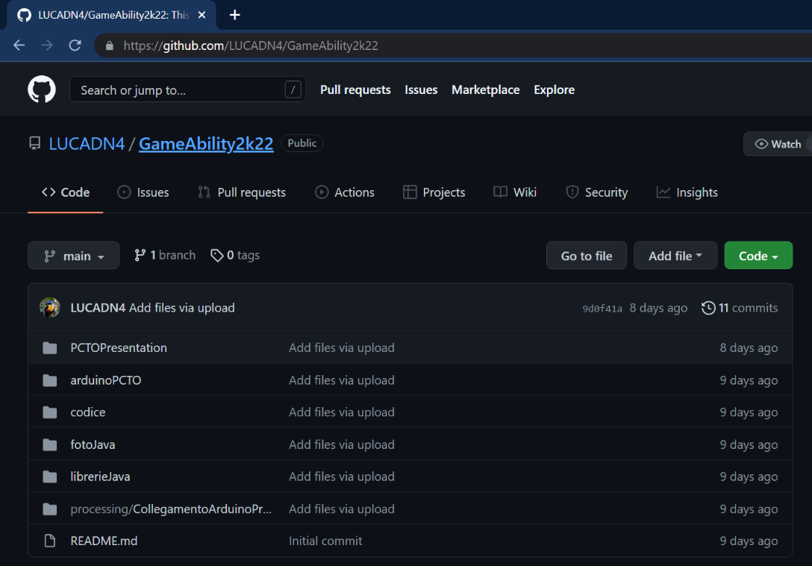

After you opened it make sure you download every .java file so you can use our complete code.

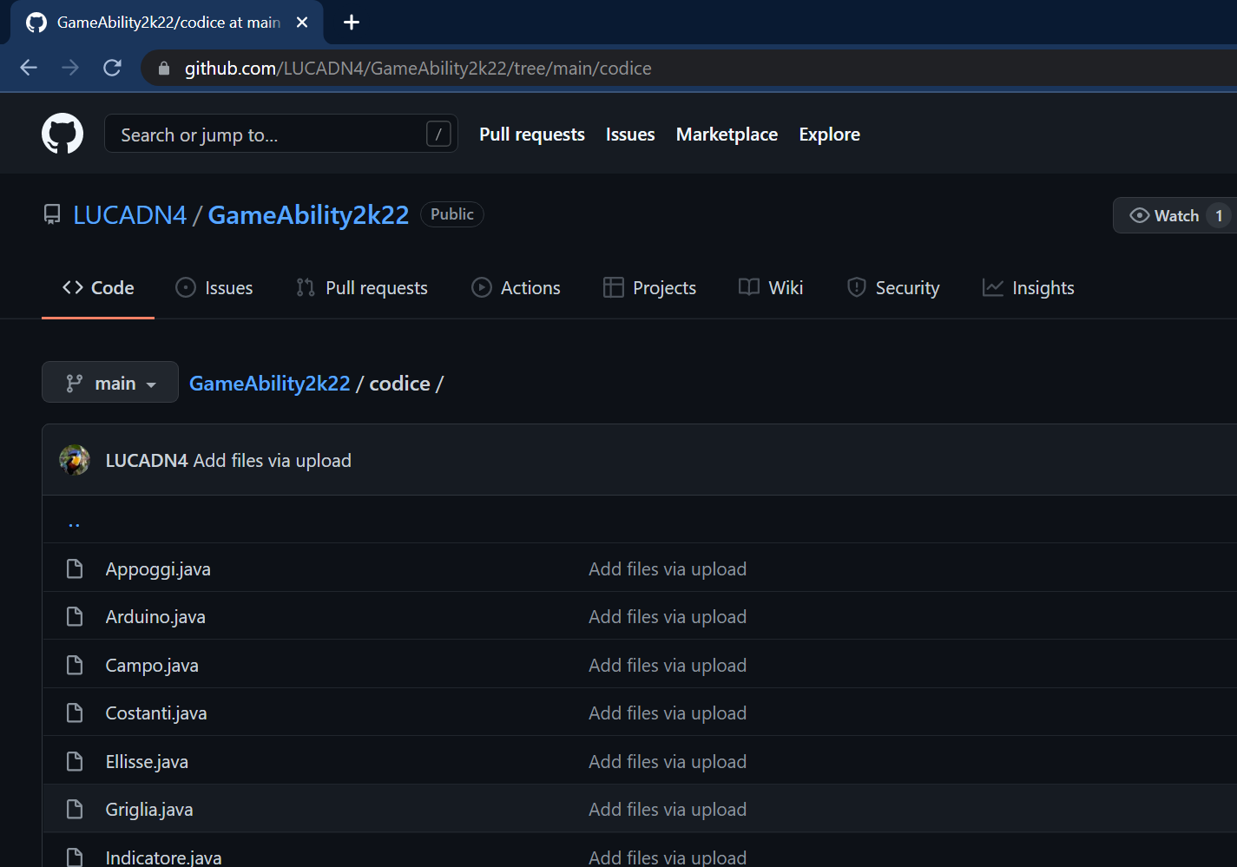

The next step is to install the software “IntellijIdea” where you have to paste the code you downloaded from our github. You can find the installation page at this link: <https://www.jetbrains.com/idea/download/#section=windows>.

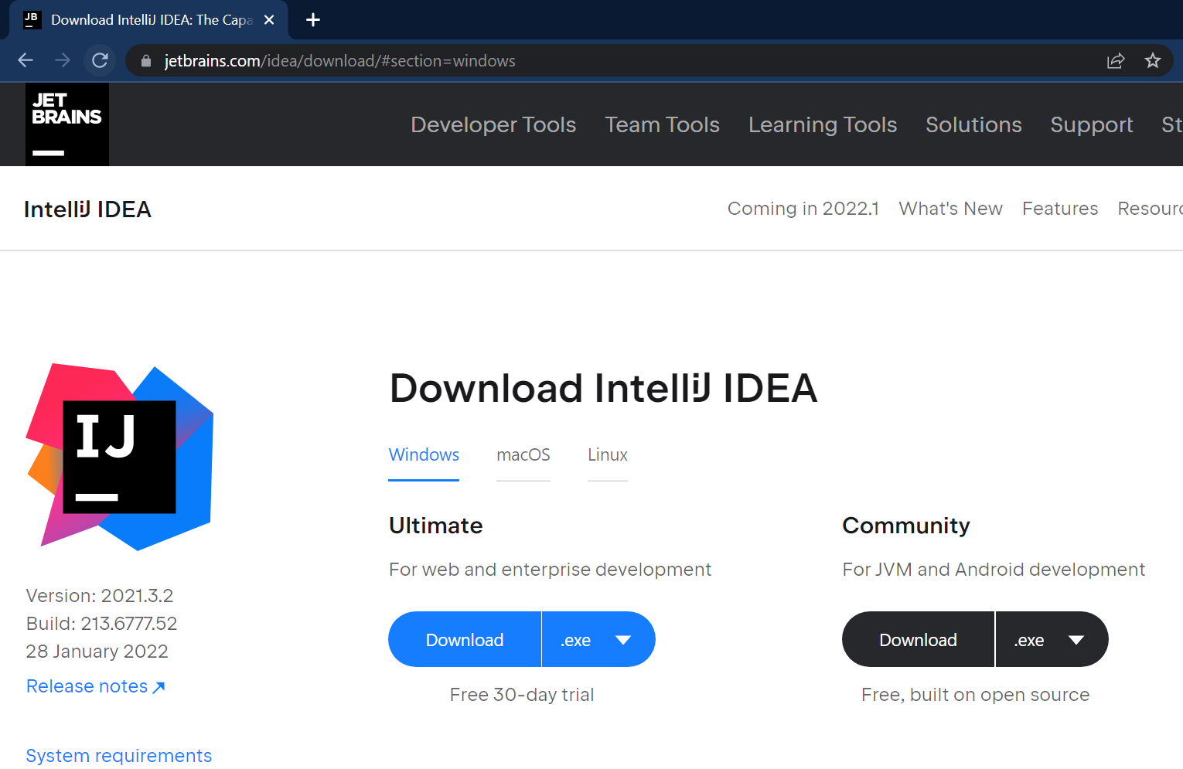

Make sure your system has the requirements needed to install the software and then install it.

When the installation is complete, please open the .exe file you have installed from the site and paste the code on the app.

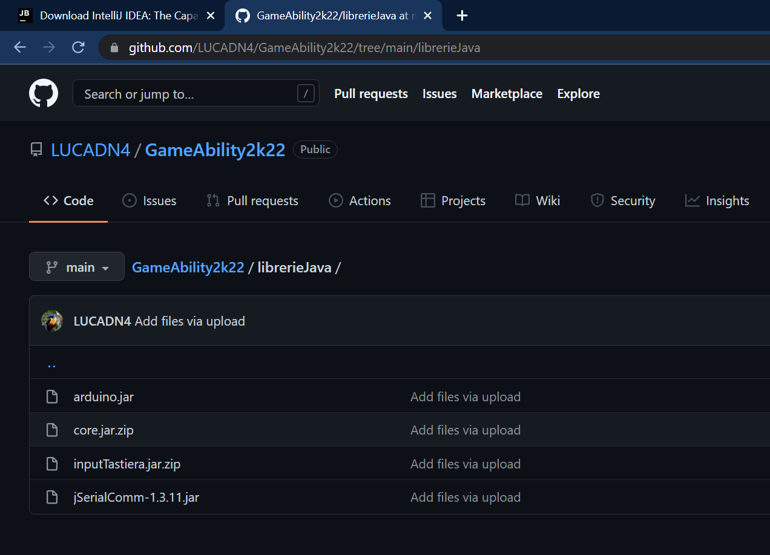You will now need our libraries to make sure the code works and you can find them always on our github repository (<https://github.com/LUCADN4/GameAbility2k22>), in the “librerieJava” folder download every file in it.

You will now include the libraries on the IntelliJIdea software, and we are going to explain it to you by simple steps:

1.Open Intellij Idea.

2.Open the project where you have pasted the entire code

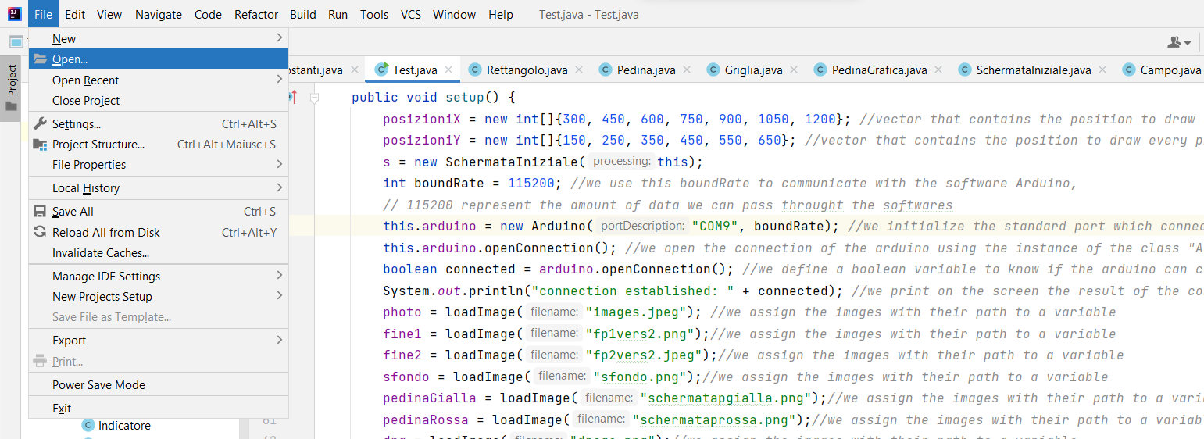

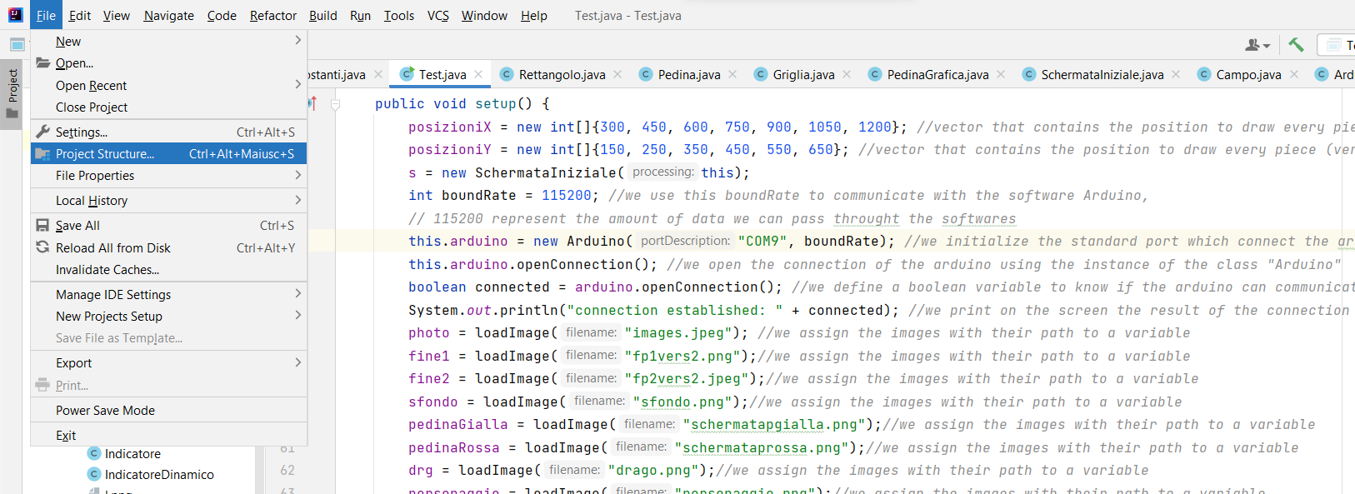3.Click on the “project structure” voice at the file voice (top left of the window)

4.Once you have clicked on “project structure” a new window will open and you have to click the voice “libraries” on the left-sided menu on the same window.

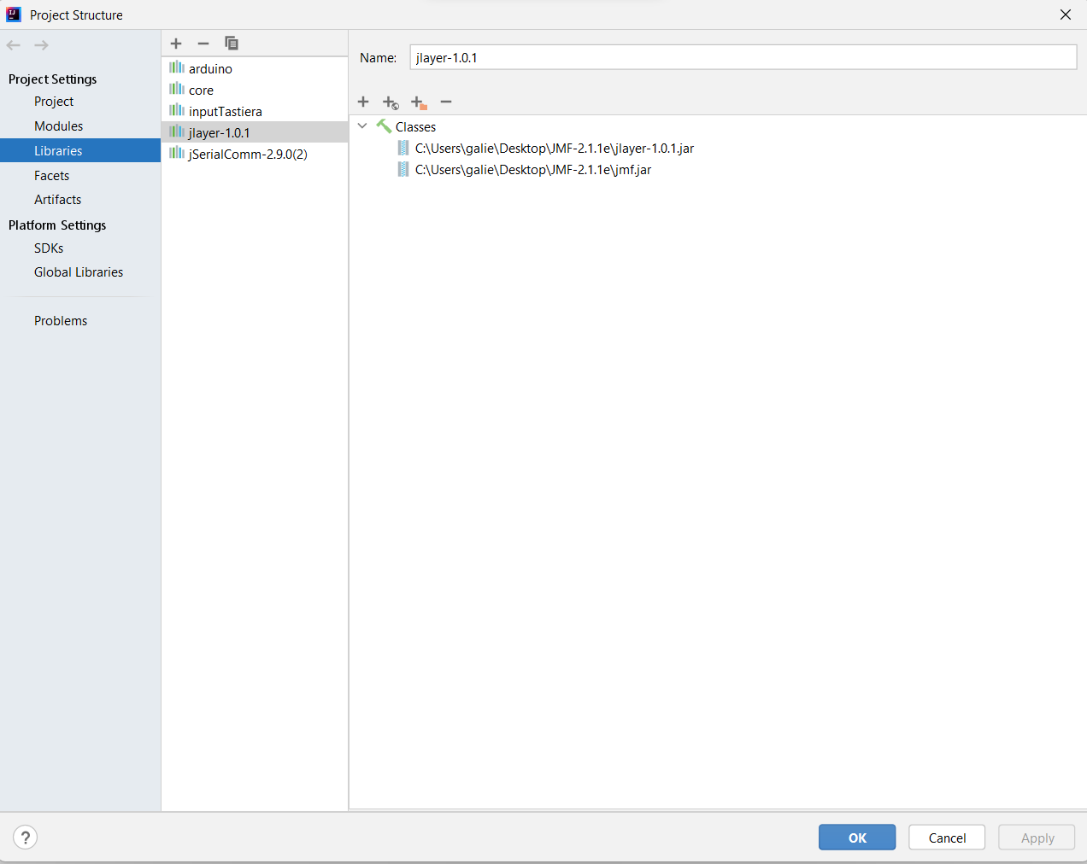

5.To add a new library to this voice you will have to click on the “plus” icon and choose the folder where the library is installed. Select all of the library and add them to the program.

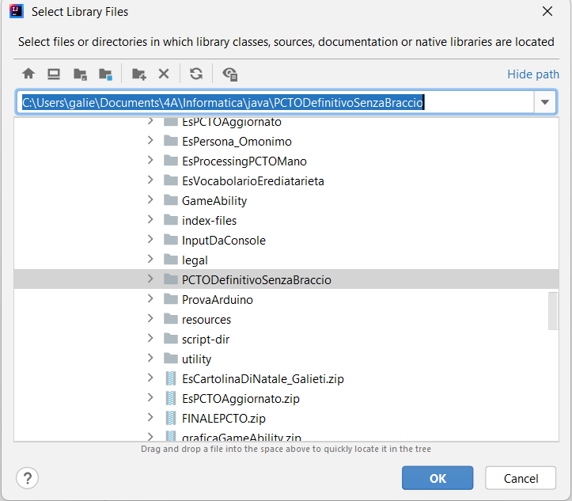

Now that you have installed successfully all of the libraries you have to run the program by clicking on the green arrow, make sure you are running the test and not other classes, at the right-top of the IntellijIdea window and say what the interface tells you to do.

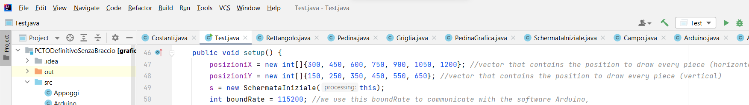

**We Hope you will enjoy playing our game and that you will like it, greetings from the MiracleMakers team.**

*This guide is provided by Luca Di Nicola, Marco Galieti and Davide Rebuffo*.